Ex. No. 8 | Modern User Interface Design using ReactJS
Date of Exercise | 18.09.2026
GitHub Host Link | https://gautham75.github.io/Web-Technology-Lab/

Aim
To design and develop a modern, responsive user interface using ReactJS by applying the following concepts:
- React components
- JSX
- Props
- State
- Event handling
- CSS styling
- Responsive design
- Reusable UI components
1. Software Required
- Node.js
- Visual Studio Code
- Web browser such as Chrome or Edge
Verify Node.js and npm installation using:
node -v
npm -v
2. Create a React Project
For a modern React setup, use Vite. Open the terminal and run:
npm create vite@latest react-ui-lab
Choose:
Framework: React
Variant: JavaScript
Move into the project folder, install dependencies, and start the development server:
cd react-ui-lab
npm install
npm run dev
The terminal will display a local URL, typically similar to:
http://localhost:5173/
Open this URL in a web browser.

3. Explain the Project Structure
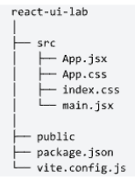
File | Purpose
main.jsx | Entry point of the React application
App.jsx | Main application component
App.css | Styling for the App component
index.css | Global CSS styles
package.json | Project dependencies and scripts

4. Clean the Default React Code
Open src/App.jsx and replace the existing content with:
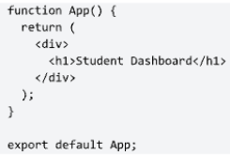
Run the project and confirm that the browser displays “Student Dashboard”.
5. Explain JSX
JSX allows HTML-like syntax to be written inside JavaScript. Example:
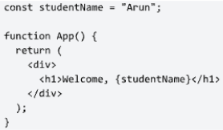
The expression {studentName} inserts a JavaScript value into JSX.
6. Create a Modern Dashboard Layout
Replace App.jsx with the following dashboard structure:
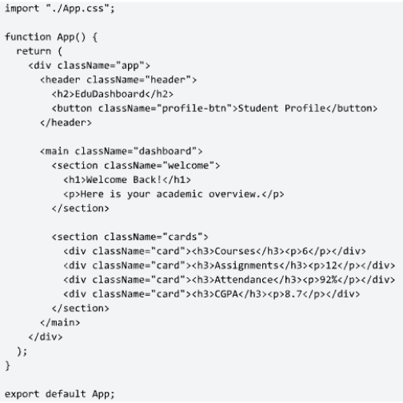
7. Add Modern CSS Styling
Open src/App.css and use the following styles:
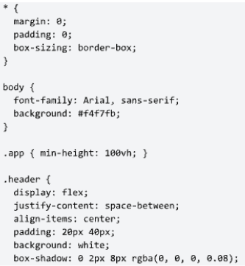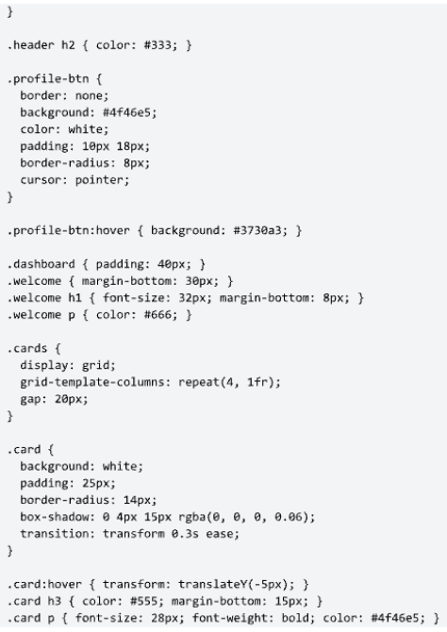
At this stage, students should see a modern card-based dashboard.
8. Teach Reusable Components
Create a folder named src/components and create StatCard.jsx inside it:
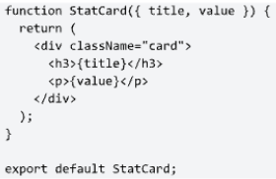
Modify App.jsx to use the reusable component:
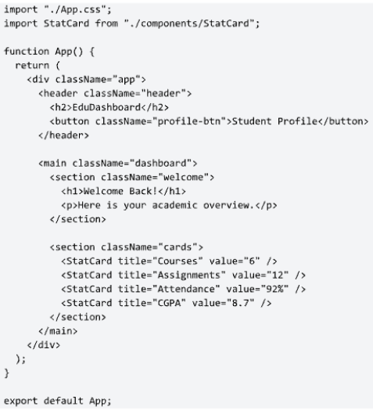
9. Explain Props
The component call below passes data from the parent to the child component:
<StatCard title = “Course” value = “6” />
The child receives those values using:
function StatCard({ title, value })
Props are data passed from a parent component to a child component.
10. Add State
Import useState and add theme switching:
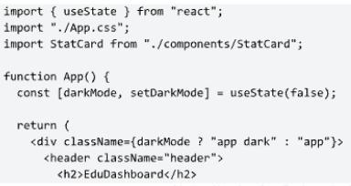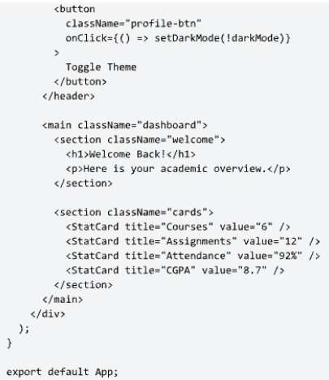
11. Add Dark Mode CSS
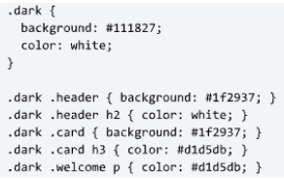
Clicking the button should switch between light and dark themes.
12. Explain State
const [darkMode, setDarkMode] = useState(false);
Part | Meaning
darkMode | Current state value
setDarkMode | Function used to update the value
false | Initial state value
When setDarkMode(!darkMode) executes, React updates the state and re-renders the interface.
13. Add a Student Course List
Add the following array inside App.jsx:
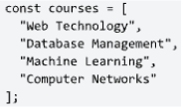
Then render the courses inside the dashboard:
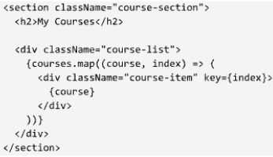
14. Style the Course List
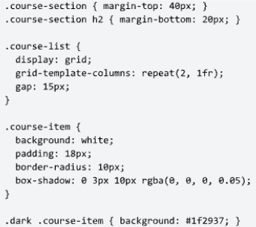
This introduces list rendering using map().
15. Add an Input Form
Add the following state variable:
const [task, setTask] = useState(“”);
Then add the form section:
<section className = “task-section”>
<h2>Add Task</h2>
<input
Type = “text”
Placeholder = “Enter a task :”
value={task}
onChange={(event) => setTask(event.target.value)}
/>
<button onClick={() => alert(task)}>Add</button>
</section>

16. Style the Form
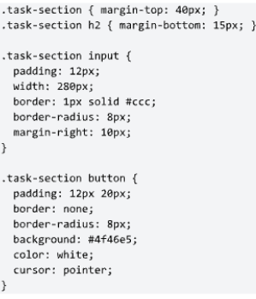
17. Teach Controlled Components
The input value is controlled by React state:
value={task}
onChange={(event) =&gt; setTask(event.target.value)}
This is called a controlled component because React state controls the input value.

18. Make the Interface Responsive
Add media queries so the interface adapts to tablet and mobile screens:
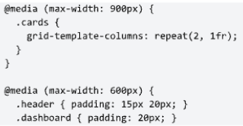
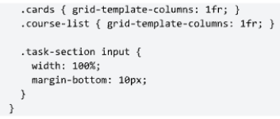
Resize the browser window to verify that the layout remains usable at different screen sizes.

19. Explain Modern UI Principles
Principle | Meaning
Consistency | Similar buttons, cards, and controls should use consistent styling.
Spacing | Use adequate whitespace and avoid overcrowded layouts.
Contrast | Text and controls should be easy to distinguish and read.
Typography | Use a clear hierarchy of font sizes and weights.
Responsiveness | The interface should adapt to different screen sizes.
Feedback | Controls should provide visible feedback to user actions.
Reusability | Repeated interface patterns should be implemented as reusable components.
Accessibility | The interface should be usable by people with different abilities.

React provides component structure and interactivity; a modern user interface comes from sound layout, spacing, typography, responsiveness, accessibility, and interaction design.

20. Add Hover Effects
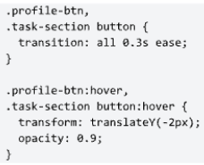

21. Add Navigation
Create Navbar.jsx inside src/components:
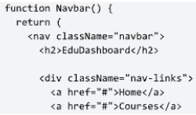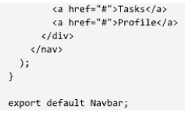
Add the following CSS:
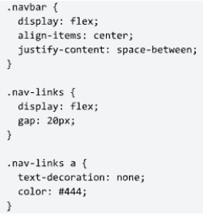
22. Final Suggested Project Structure
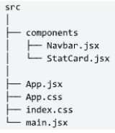
23. Student Lab Activity
Problem: Design a modern Student Dashboard using ReactJS. The application should contain:
1. Navigation bar
2. Welcome section
3. At least four statistic cards
4. Course list
5. Task input field
6. Button event
7. Light/dark theme
8. Responsive layout
9. Hover effects
10. Reusable components
Program
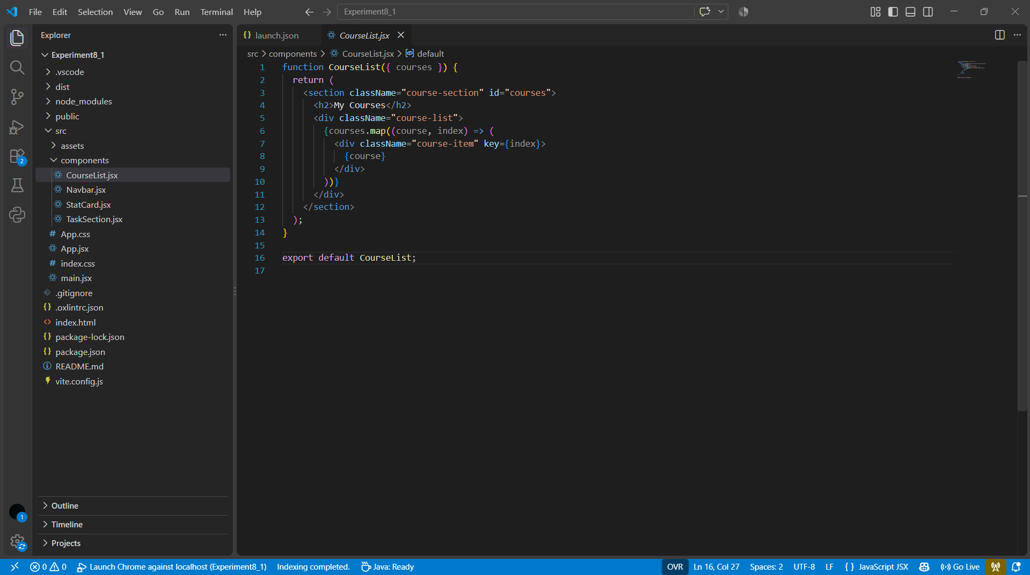
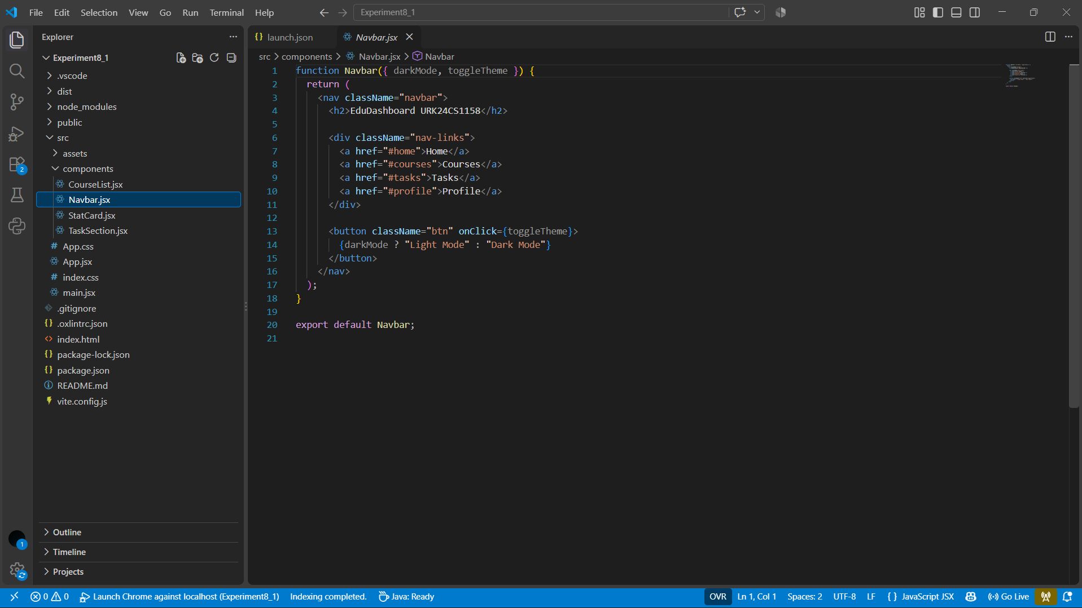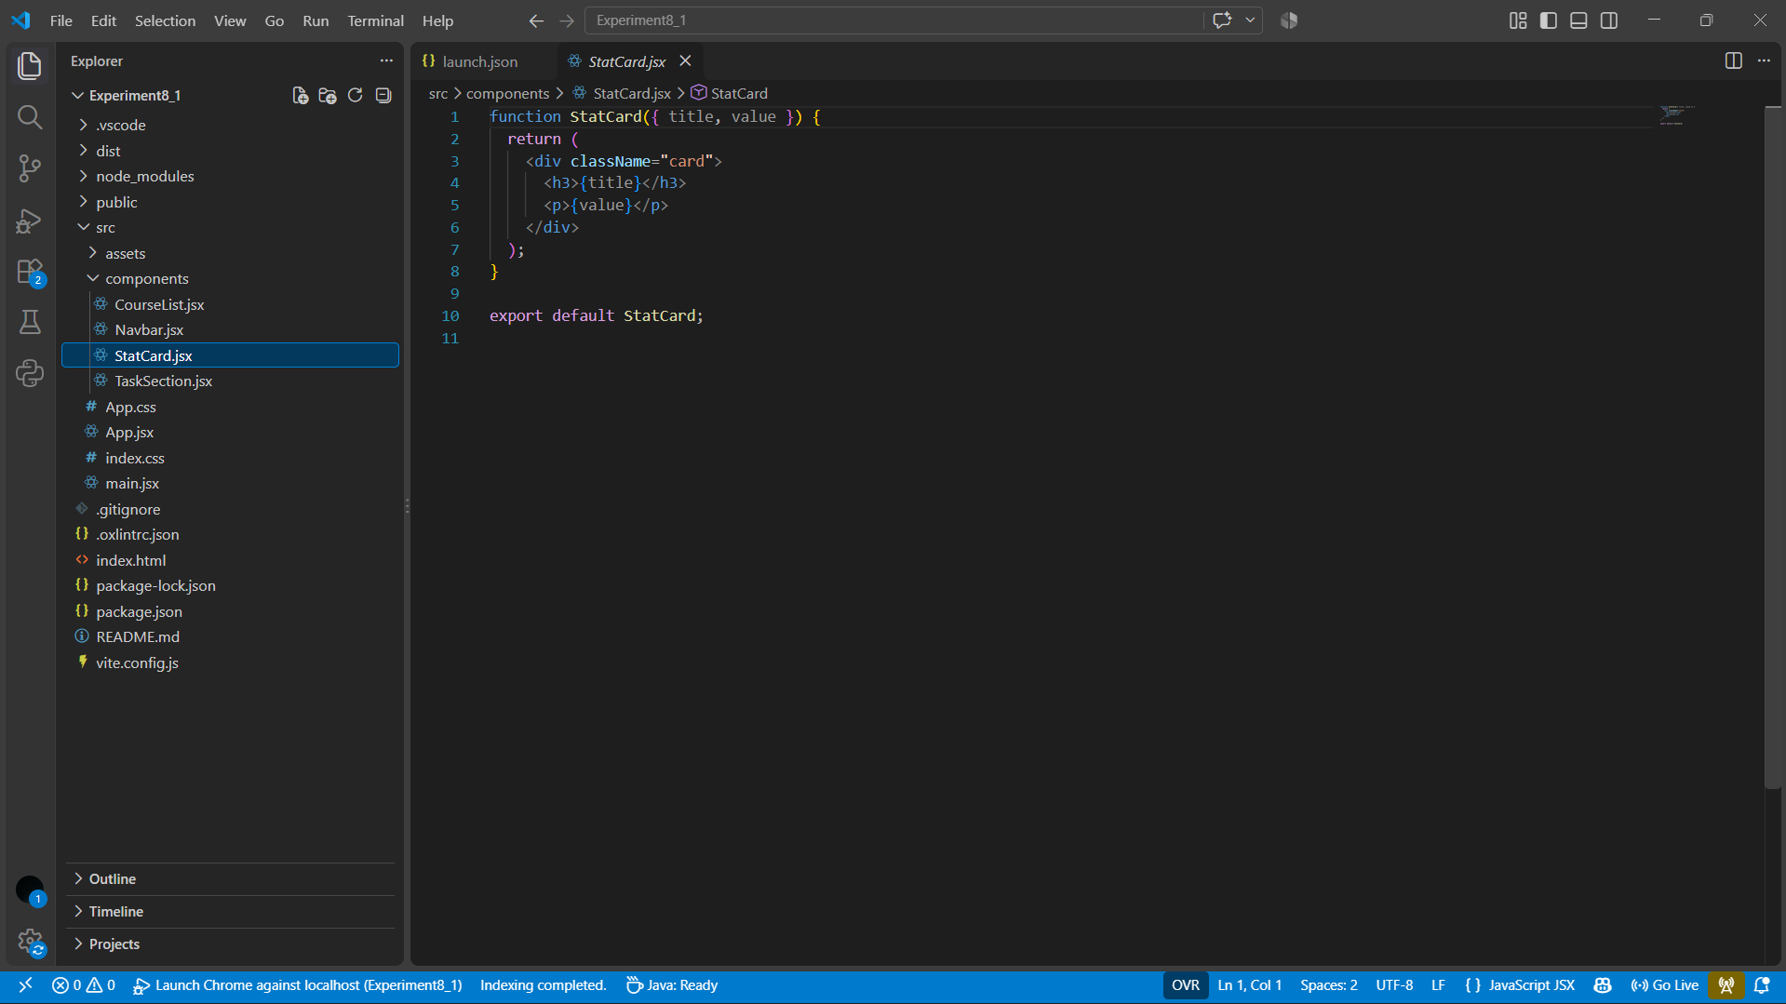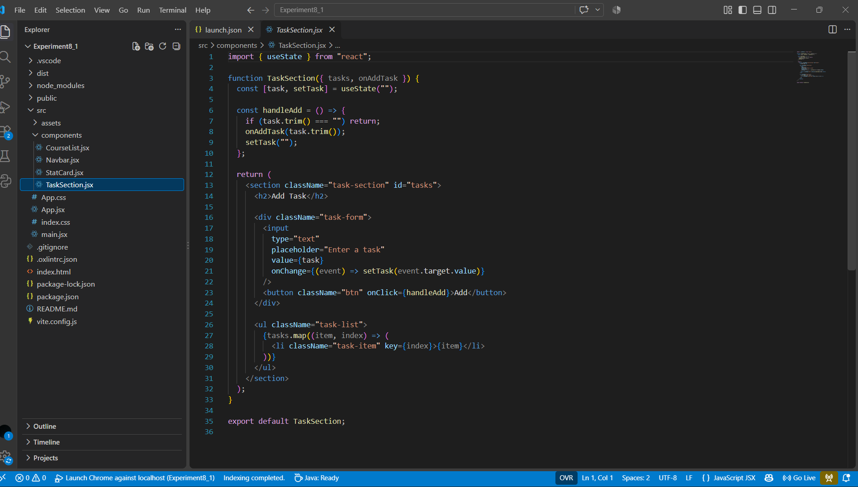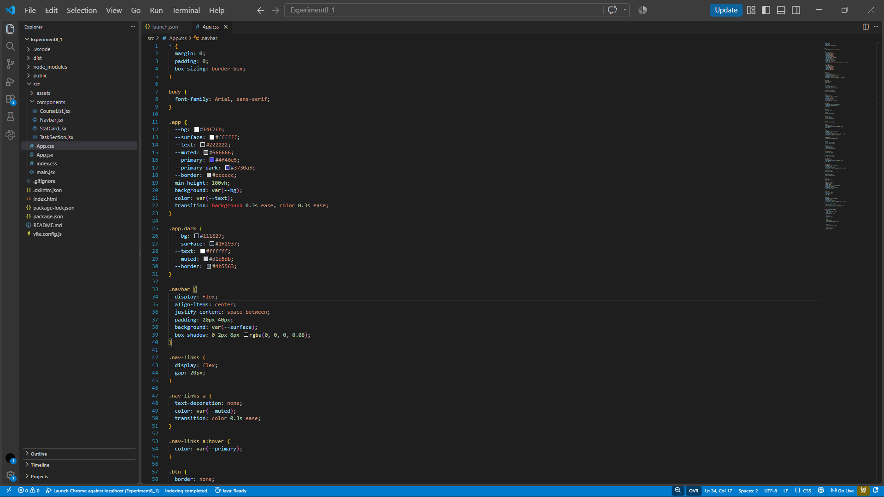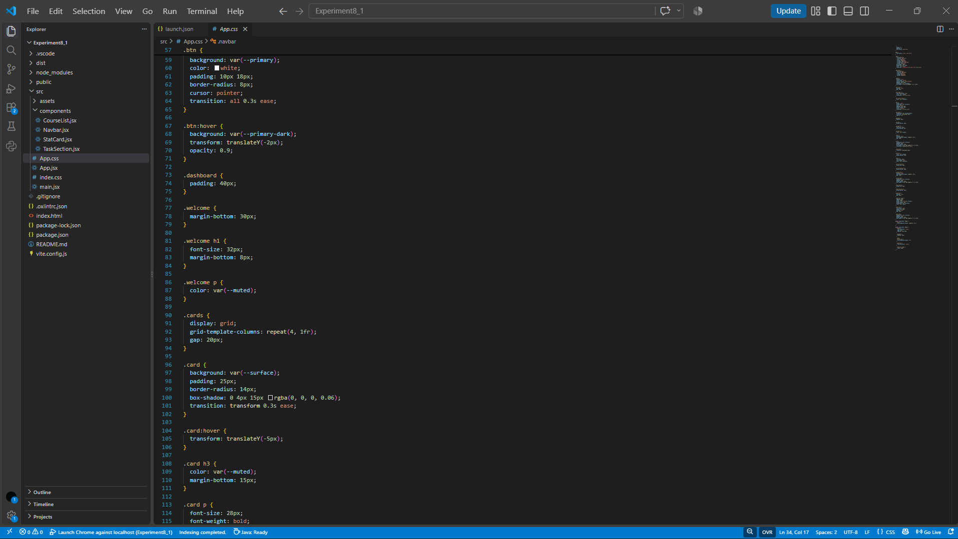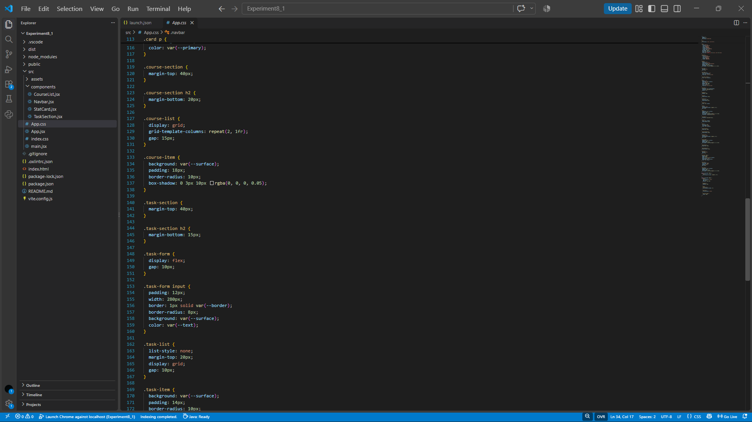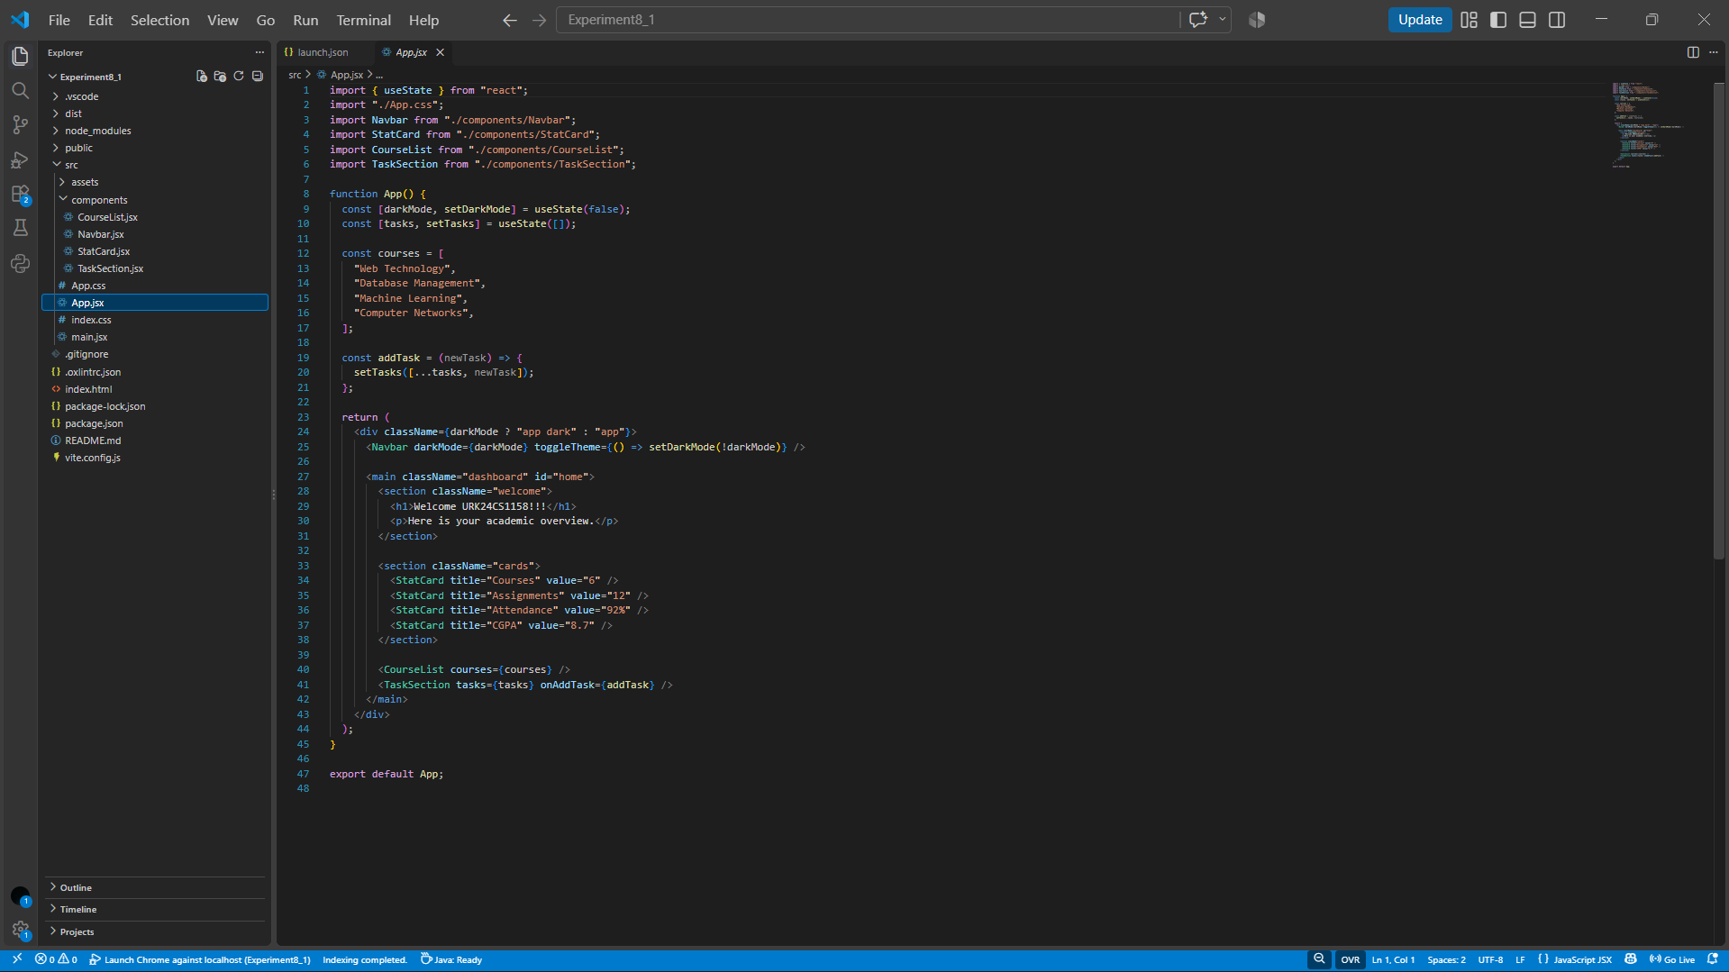

Output
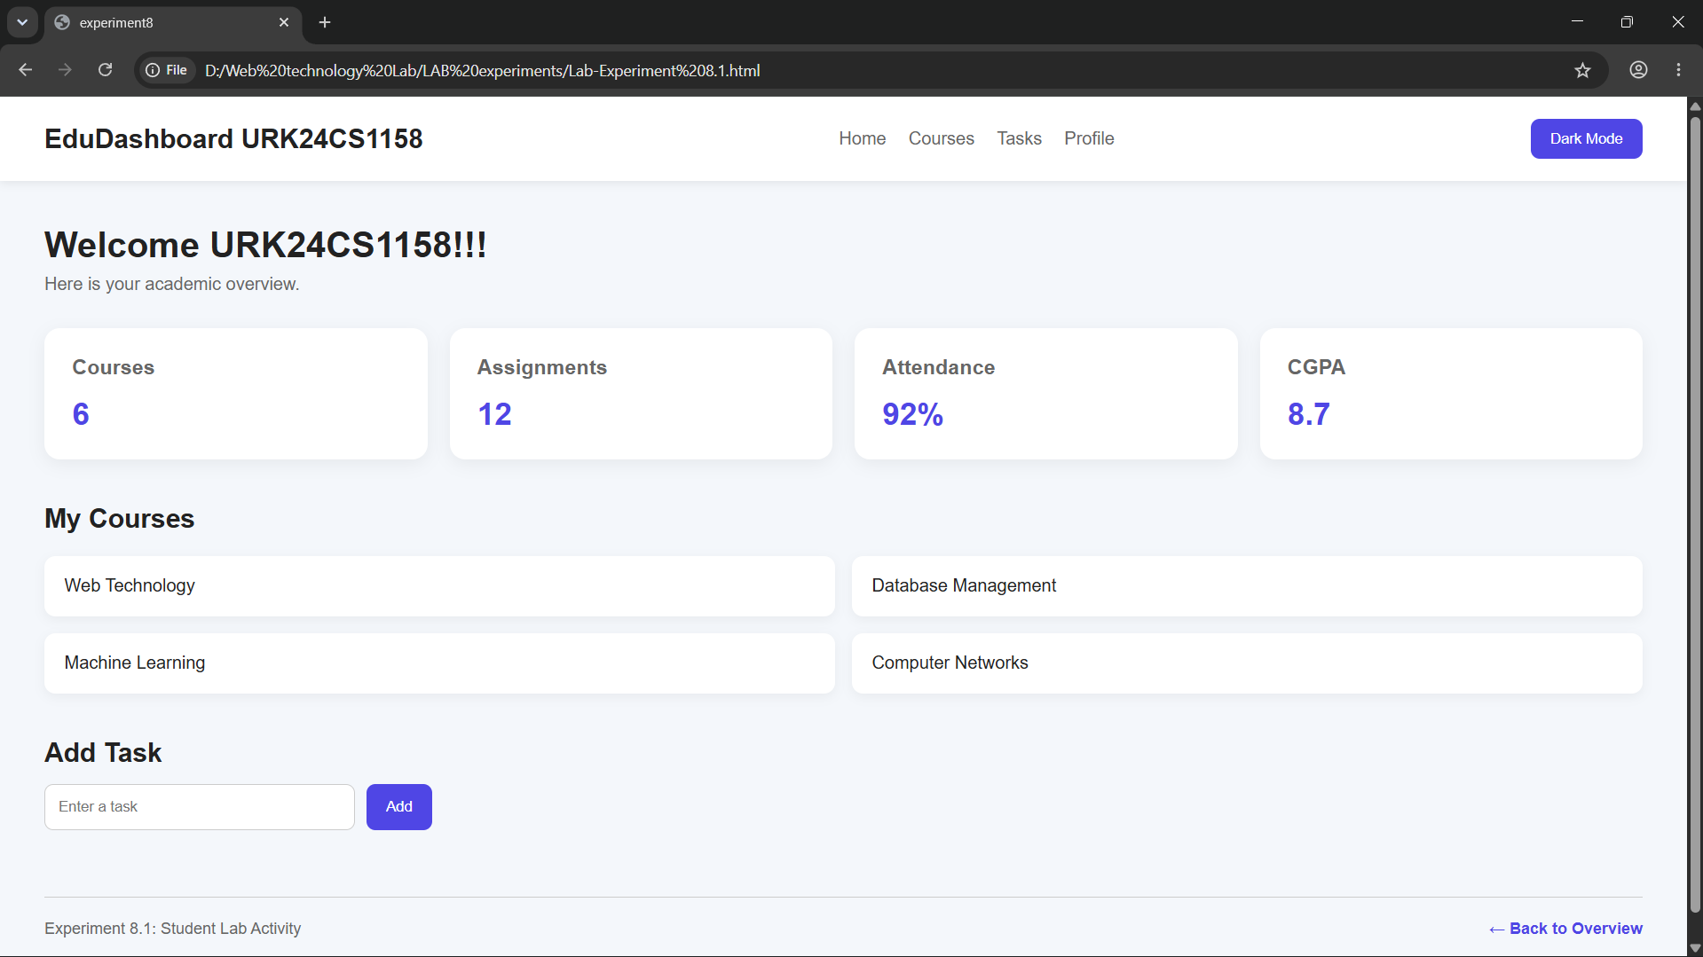
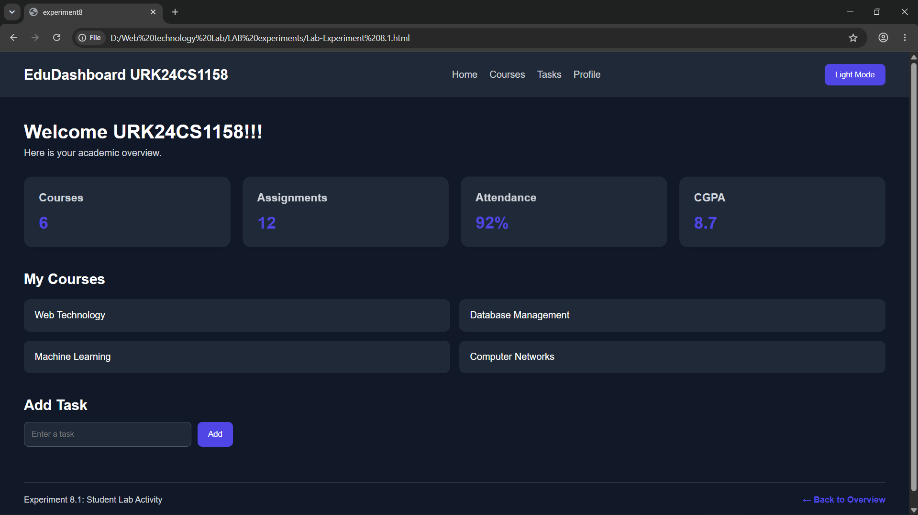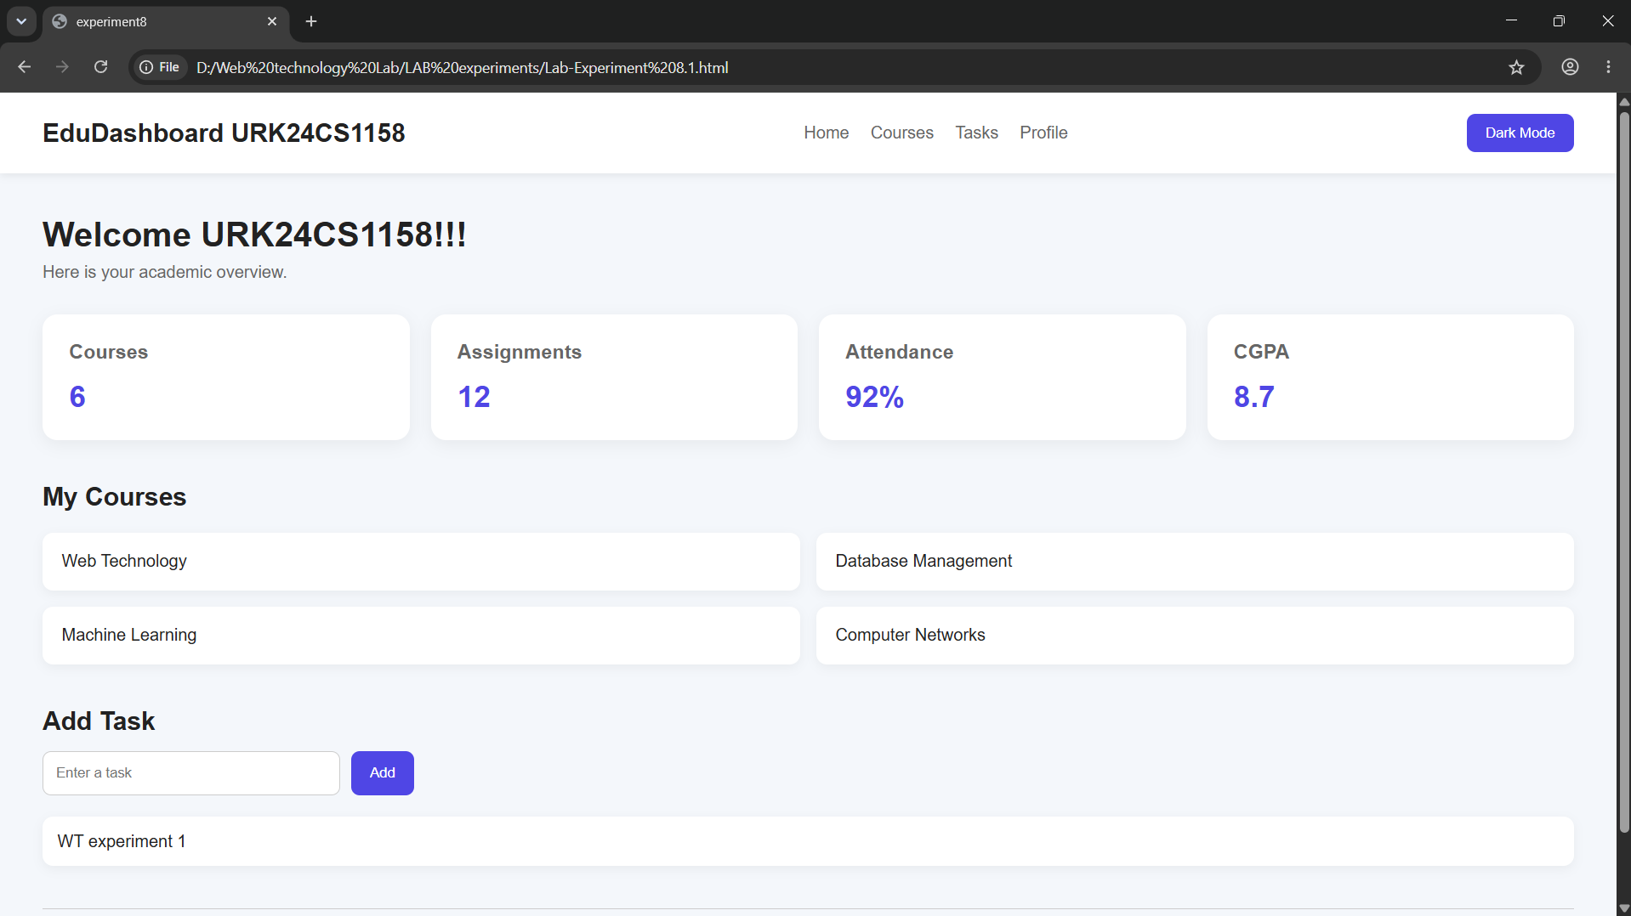
24. Additional Student Challenge
Ask students to improve the application by adding the following features:
- Profile image
- Search bar
- Notification icon
- Progress bars
- Course completion percentage
- Task deletion
- Task completion
- Sidebar
- Responsive menu
Program
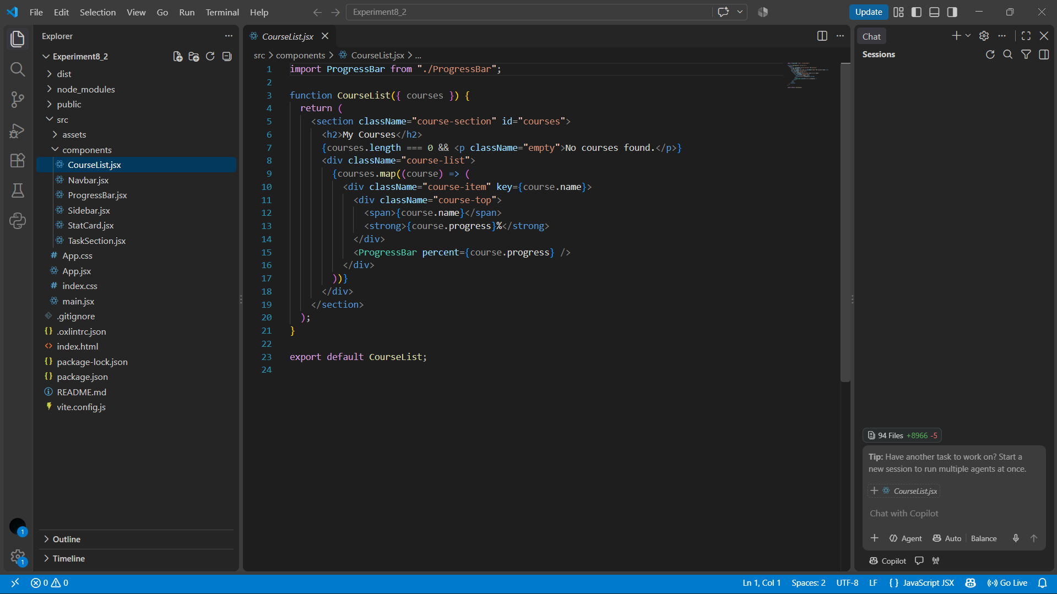
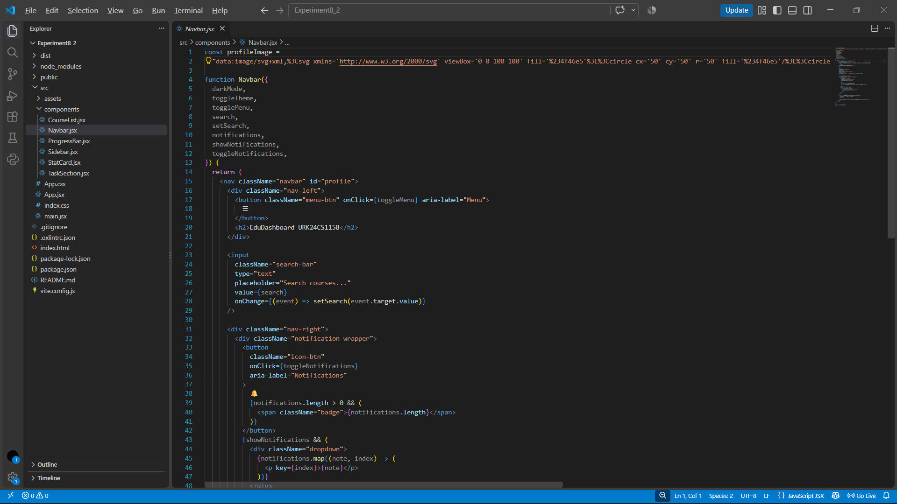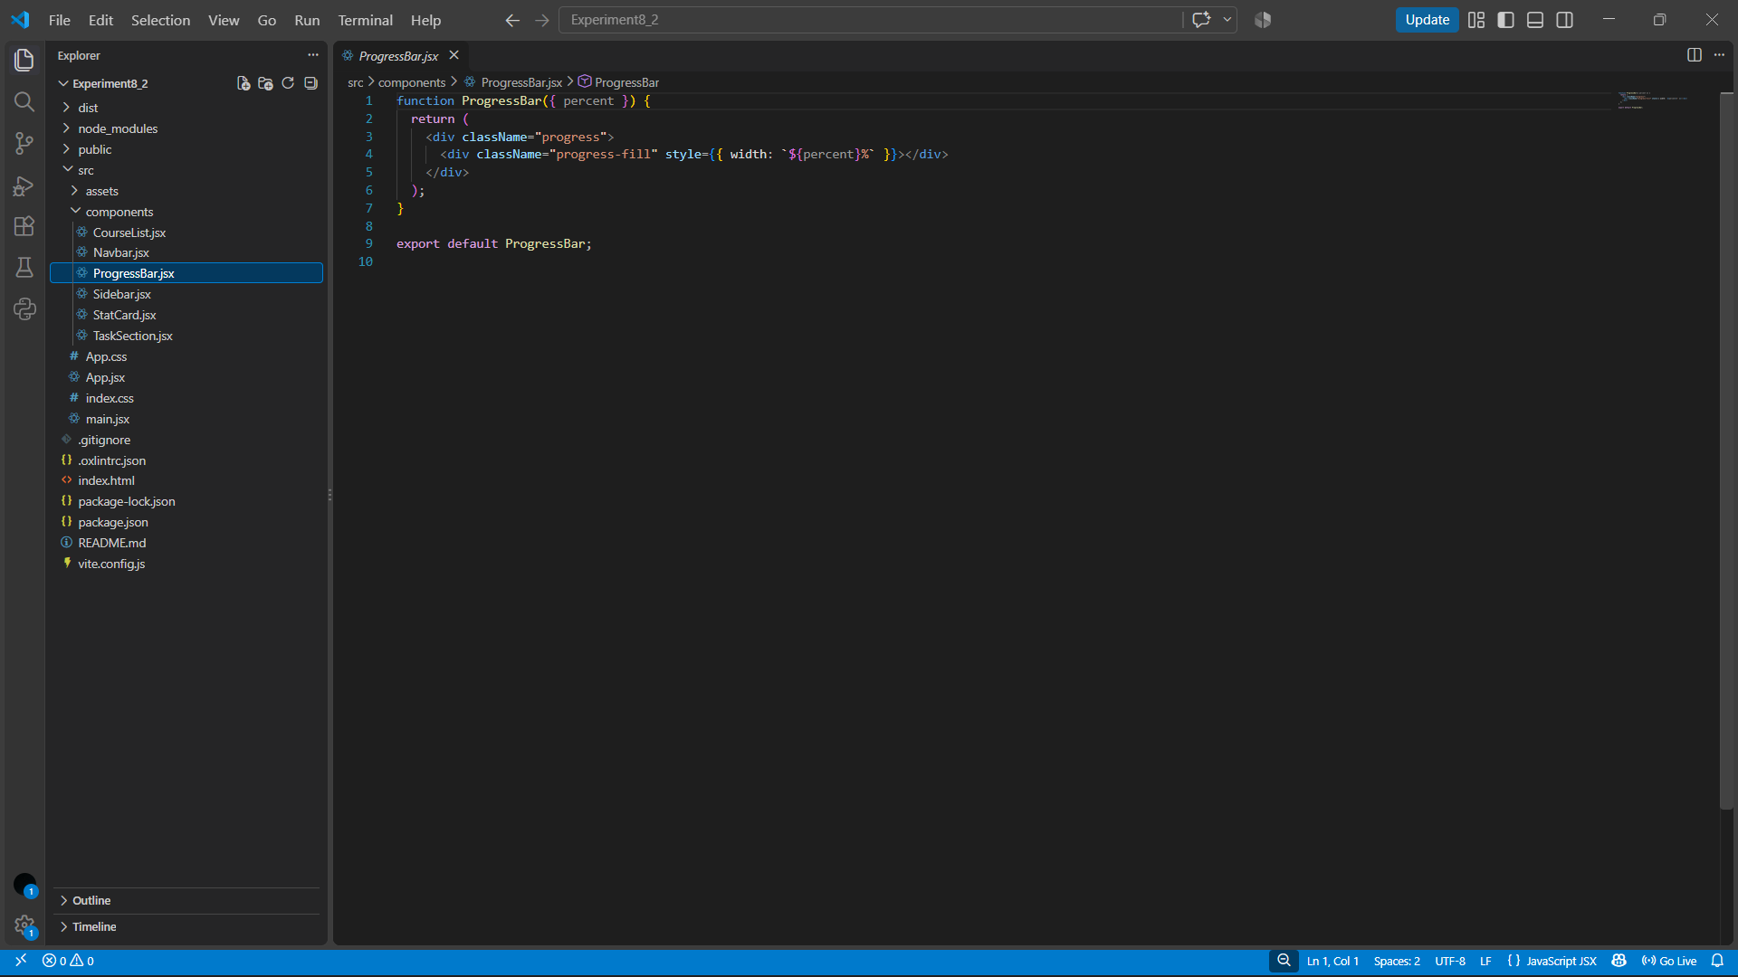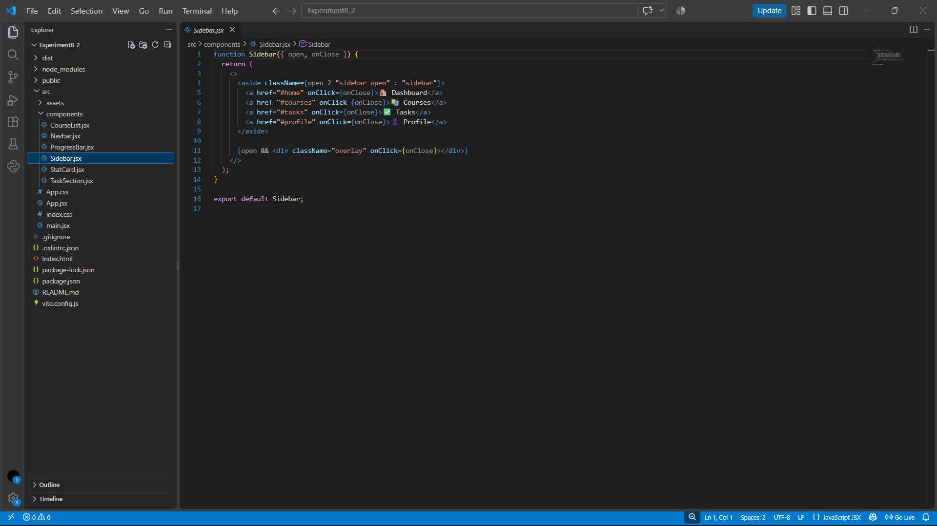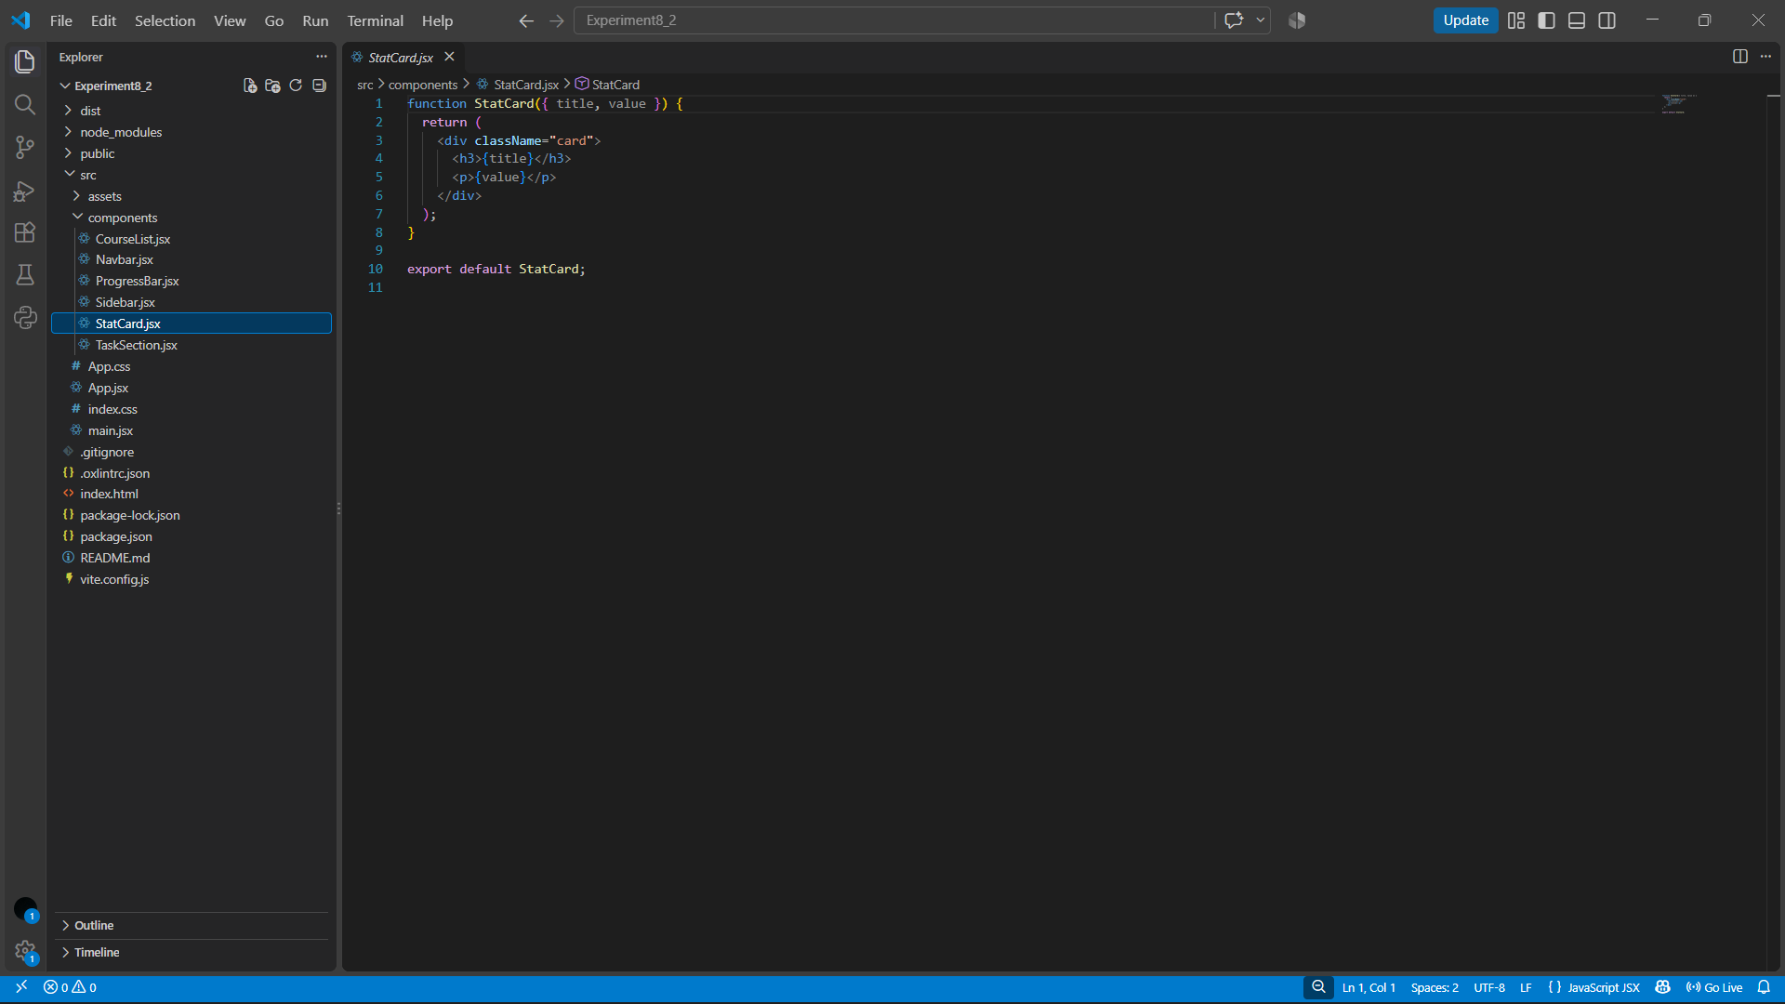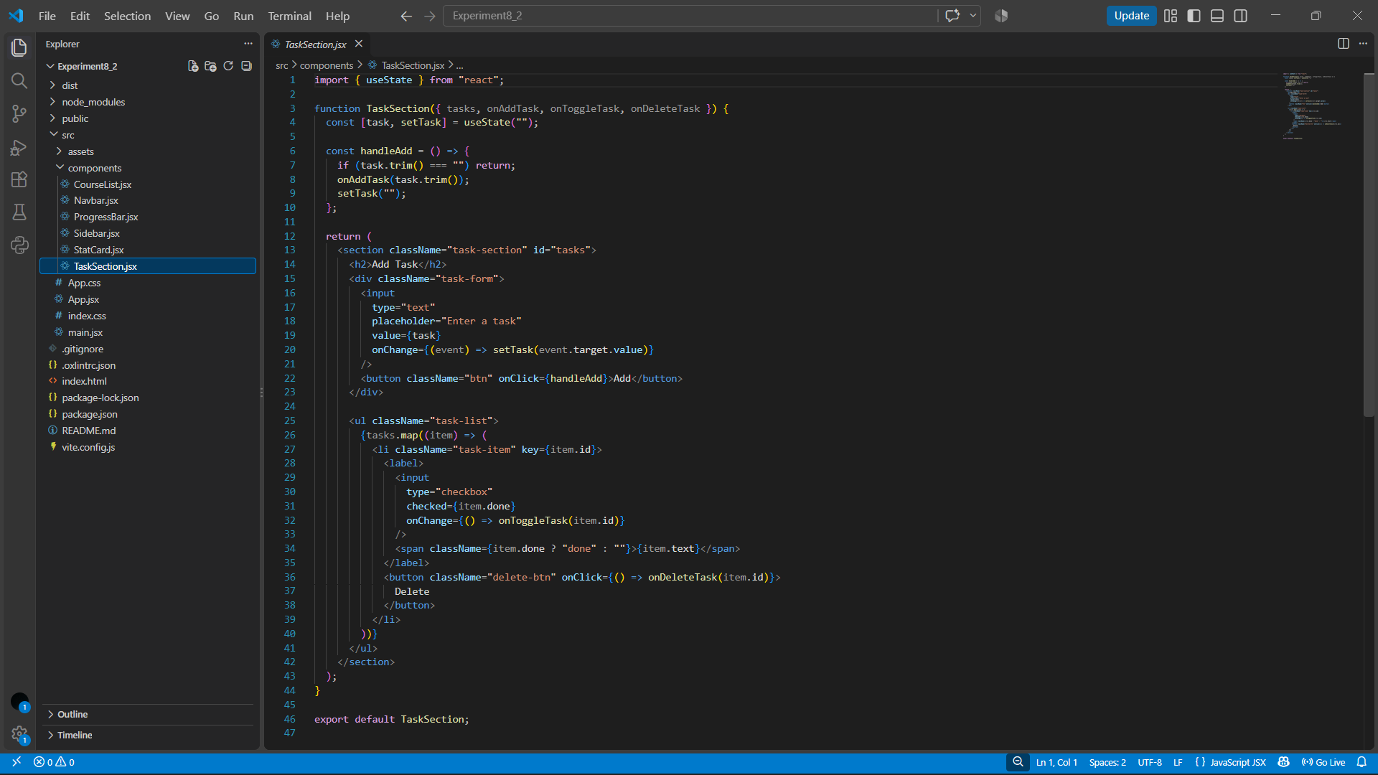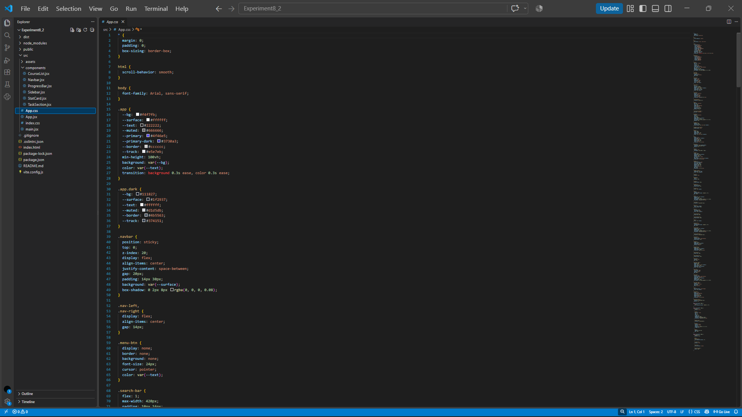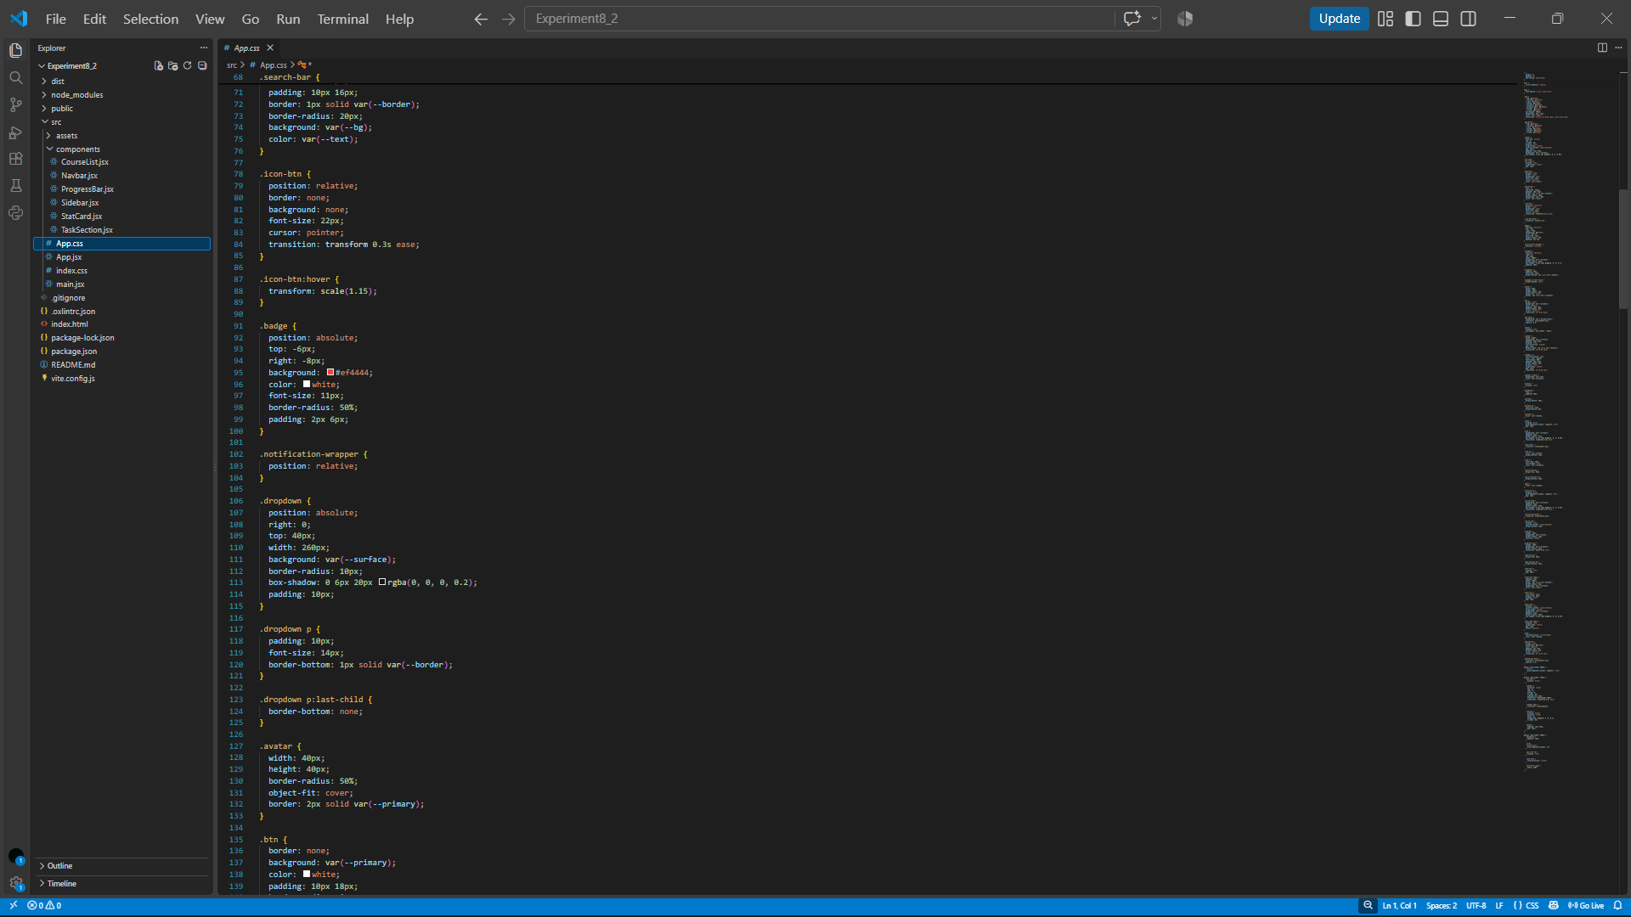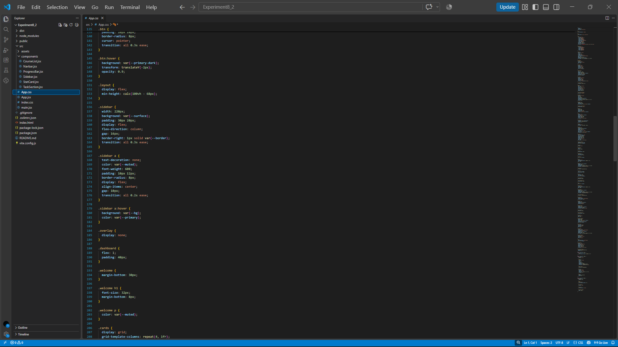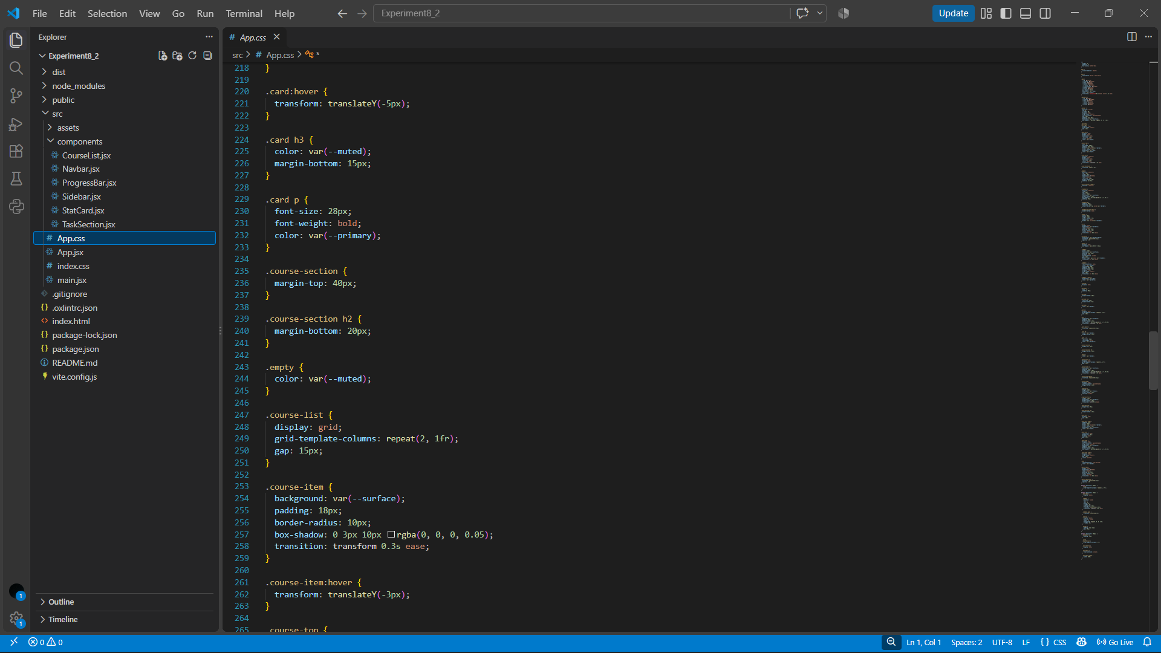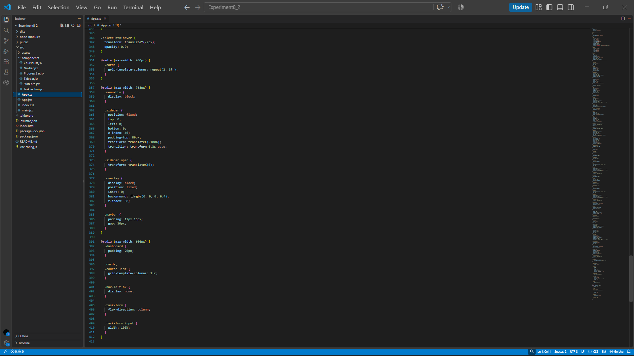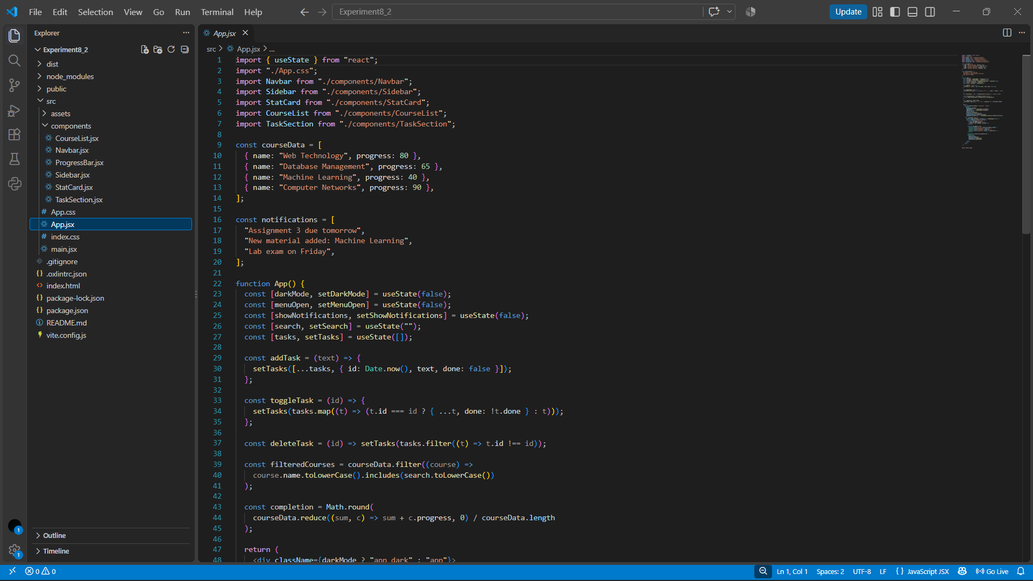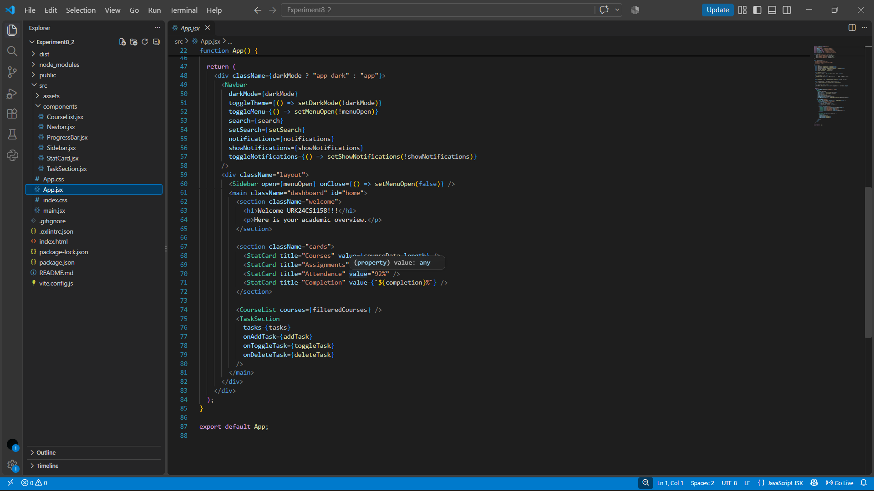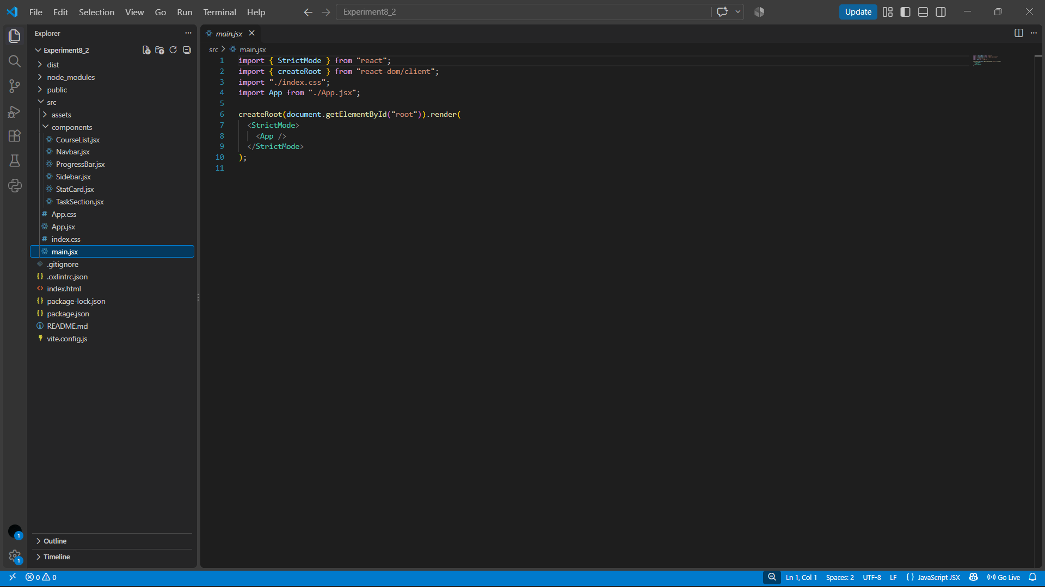

Output
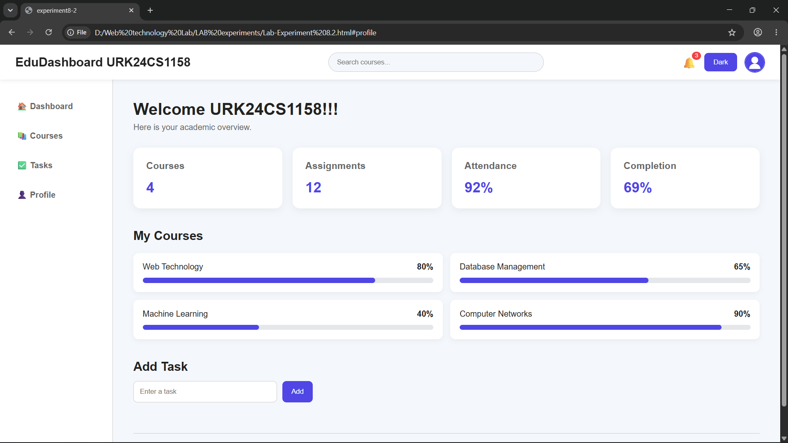
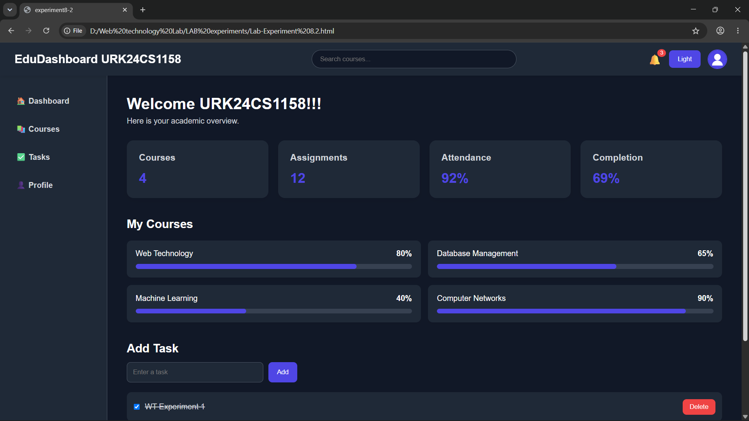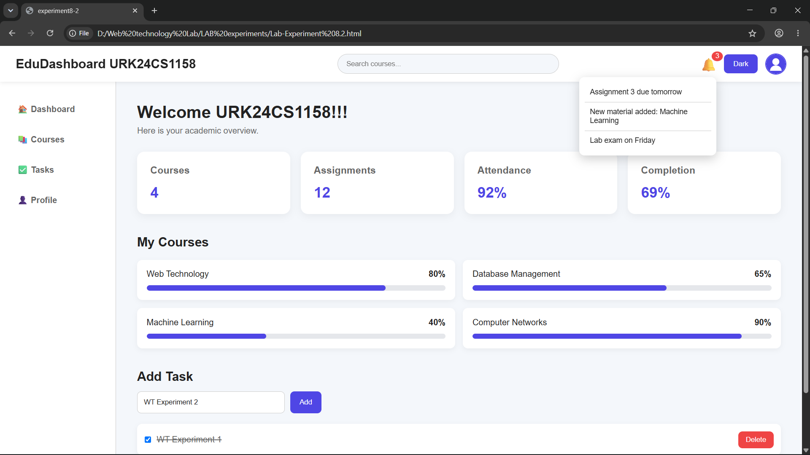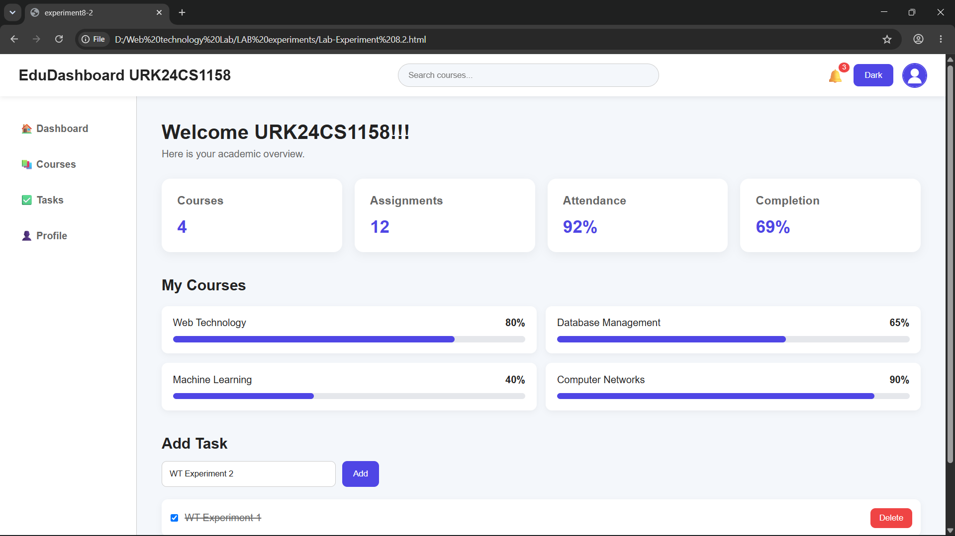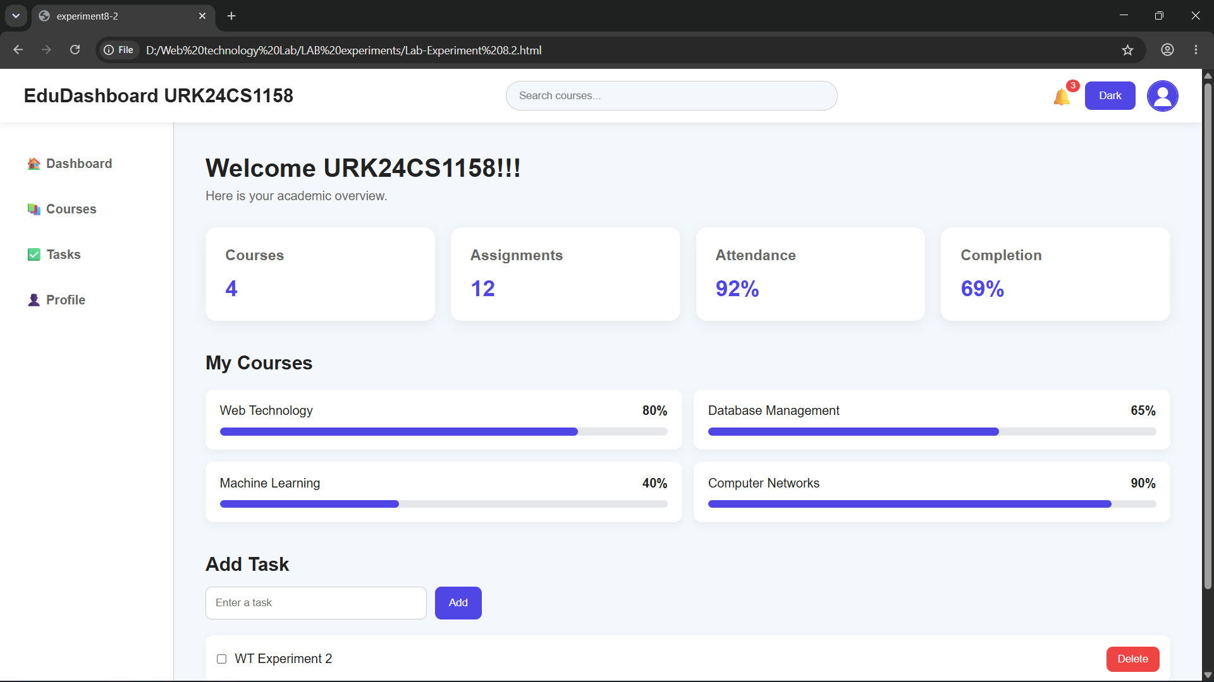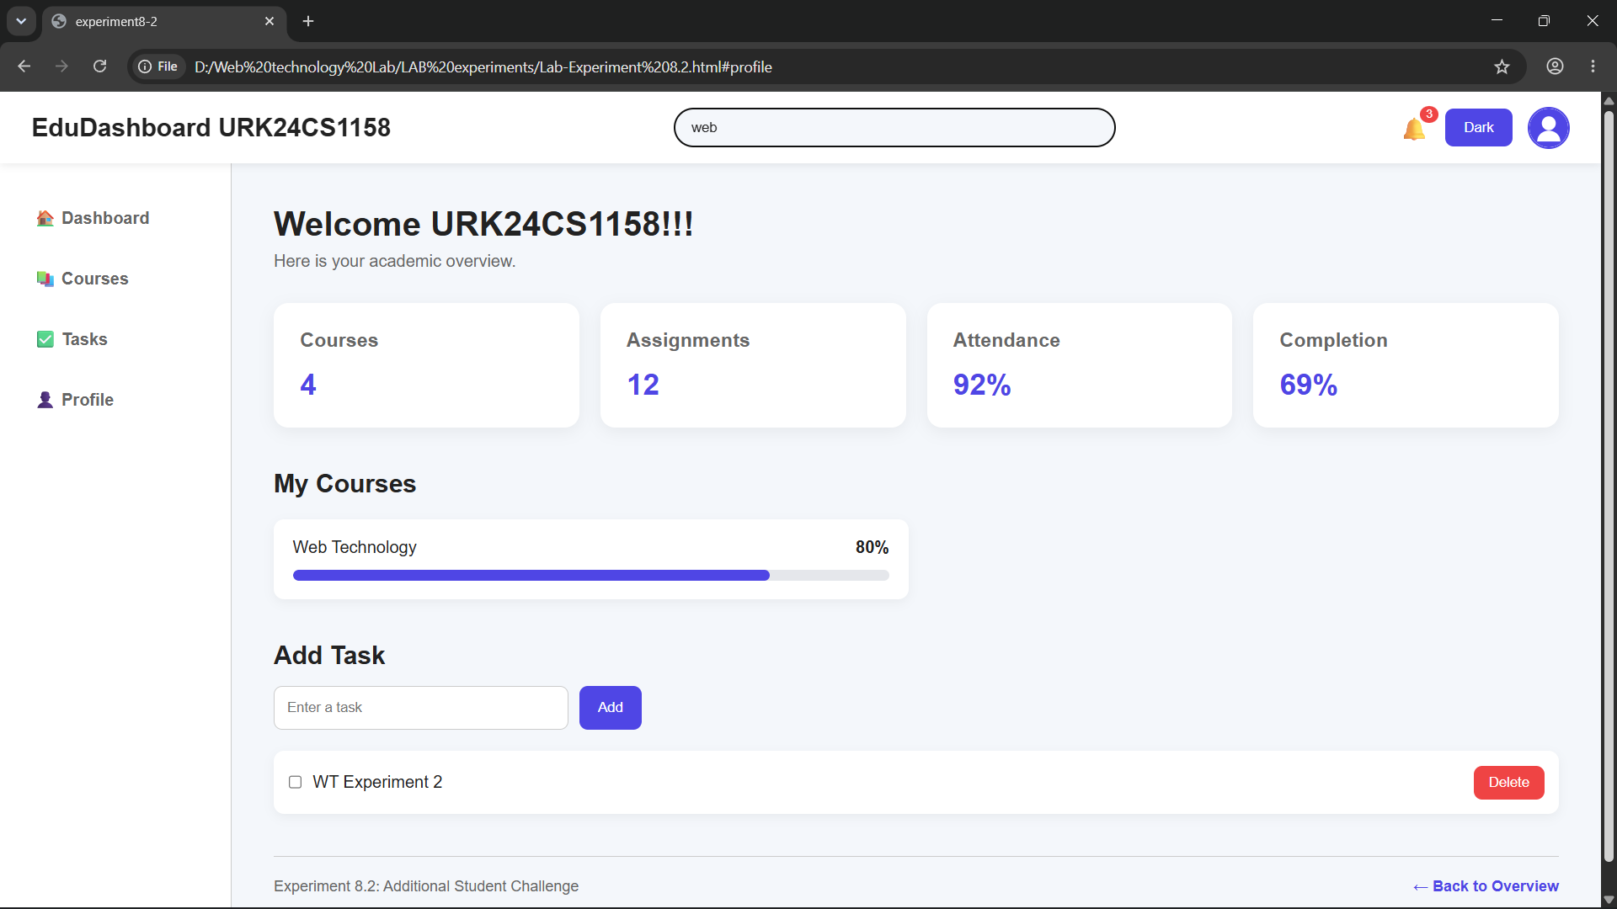
25. Concepts Covered
Concept | Example
JSX | <h1>Hello</h1>
Components | StatCard
Props | titlevalue
State | useState()
Events | onClick
Input handling | onChange
Lists | map()
Conditional styling | Dark mode
CSS Grid | Dashboard cards
Media Queries | Responsive UI

26. Viva Questions
1. What is ReactJS?
A JavaScript library for building user interfaces using reusable components.
2. What is JSX?
A syntax that lets you write HTML-like code inside JavaScript.

3. What is a React component?
A reusable piece of UI written as a function that returns JSX.
4. Functional vs class components?
Functional components are simple functions that use hooks, while class components use ES6 classes and lifecycle methods.
5. What are props?
Read-only data passed from a parent component to a child component.
6. What is state?
Data inside a component that can change and makes the UI update when it does.
7. What is useState()?
A hook that adds a state variable and an update function to a functional component.
8. Props vs state?
Props are passed in from outside and cannot be changed by the child, while state is owned by the component and can be changed.
9. What is event handling in React?
Responding to user actions like clicks or typing using handlers such as onClick and onChange.
10. What is a controlled component?
An input whose value is controlled by React state through value and onChange.
11. Why is the key attribute used in lists?
It gives each list item a unique identity so React can update the list efficiently.
12. What is responsive web design?
Designing a page so it adapts to different screen sizes like mobile, tablet and desktop.
13. What is CSS Flexbox?
A one-dimensional layout system that arranges items in a row or column.
14. What is CSS Grid?
A two-dimensional layout system that arranges items in rows and columns.
15. What is the purpose of media queries?
To apply different CSS styles depending on screen width or device type.
16. What is component reusability?
Writing a component once and using it many times with different props.
17. Why divide large React apps into components?
It makes the code easier to read, reuse, test and maintain.
18. What is the purpose of npm?
It installs and manages the packages and dependencies a project needs.
19. What is Vite?
A fast build tool and development server for creating modern React projects.
20. What happens when React state changes?
React re-renders the component and updates the screen with the new data.

Result
Thus, a modern and responsive user interface was successfully designed and implemented using
ReactJS with reusable components, JSX, props, state, event handling, CSS styling, responsive
layouts, and theme switching.

